

CREDIT CARD DEFAULT PREDICA- TION

# Wireframe documentation



Vishal Singh

# DECEMBER 20, 2022

INEURON

1. The first page displays the pop up window where the user has to provide specific details such as Gender, Repayment status, Bill amount , Age etc*.*

* All the information will be used to predict the results.

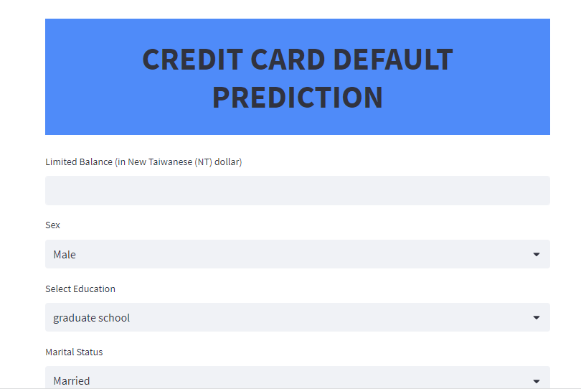

2. After entering all the data we will get the predictions at the bottom page, i.e if the borrower will default or not.

* In this case the Borrower will not be a Defaulter in next month.

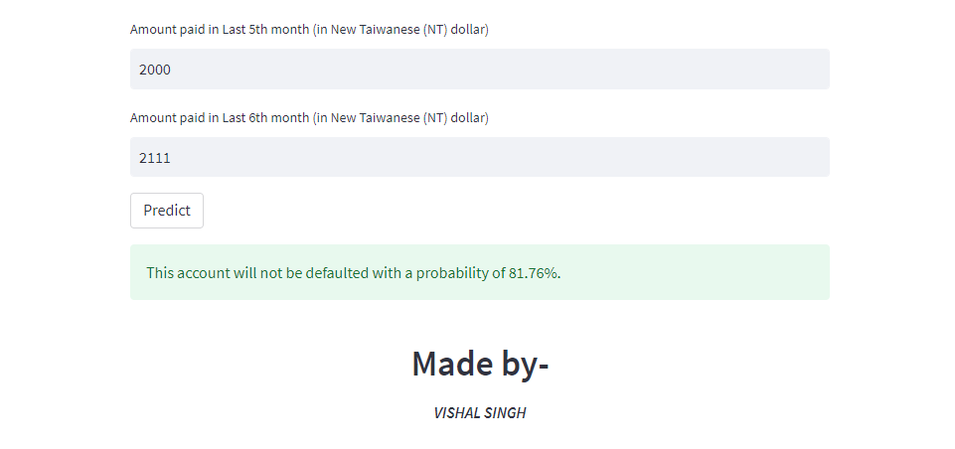

* In this case the Borrower will be a Defaulter in next month.

